**Strategies and Tools for Fake Message Detection in digital world**

DR.N. SWAPNA GOUD- Assistant Professor, Department of Computer Science, Anurag University

B. DINESH KUMAR - Student, Department of Computer Science, Anurag University

B. SREEJA - Student, Department of Computer Science, Anurag University

B. SHUSHANTH - Student, Department of Computer Science, Anurag University

**Abstract**

Social media network is one of the important parts of human life based on the recent technologies and developments in terms of computer science area. This environment has become a famous platform for sharing information and news on any topics and daily reports, which is the main era for collecting data and data transmission. There are various advantages of this environment, but in another point of view there are lots of fake news and information that mislead the reader and user for the information needed. Lack of trust-able information and real news of social media information is one of the huge problems of this system. To overcome this problem, we have proposed an integrated system for various aspects of blockchain and natural language processing (NLP) to apply machine learning techniques to detect fake news and better predict fake user accounts and posts. The Reinforcement Learning technique is applied for this process. To improve this platform in terms of security, the decentralized blockchain framework applied, which provides the outline of digital contents authority proof. More specifically, the concept of this system is developing a secure platform to predict and identify fake news in social media networks.

**1. INTRODUCTION**

Based on the concept of blockchain in social media, our system will exploit the advantages of blockchain's security, immutability, and transparency to create trust among shared news. We will provide a hypothesis, which could be implemented in a decentralized social media to provide authenticity of news among users. Social media is the source of all kinds of global and local news for most people in this generation. But it backfires when an individual or organization uses it to spread fake news. Because, in social media, clickbait stories take a brief time to spread exponentially. The news becomes viral worldwide just within days. These opportunist organizations or individuals are taking advantage of people’s tendency to share appealing news without knowing its authenticity or consequences. Social media has been influenced by the 1840s introduction of the telegraph in the US, which connected the country. Since then, the use of social media is increasing day by day. Table 1 contains the number of active users of the leading social media platforms according to July 2018. So, as we can see that Facebook is at the epicenter of media attention, recently, Facebook has implemented a feature to flag fake news on the site. Although they have cleared it with public announcements that using an automated way, they are investigating the ability to detect fake articles. The fake news published on social media almost looks like to be real. The reason for posting false news stories is to fetch people’s attraction. Thus, they may earn more money with more page views. Almost every country uses social media as a source of news. In this paper, we will discuss a way to detect these fake news stories. We will use the concept of decentralization, Ethereum smart contract, and use BFS algorithm for calculating proximity of a user.

# 1.2 Scope of the Project:

### The project aims to develop a decentralized social media platform leveraging blockchain technology to ensure security, immutability, and transparency of shared news. It involves integrating algorithms like the Breadth-First Search (BFS) algorithm to calculate user proximity and detect fake news, alongside Ethereum smart contracts for transaction execution and trust maintenance. Through mechanisms to authenticate news articles and flag fake news, the platform will offer a reliable means of verifying the authenticity of shared content. Thorough testing, user-friendly interfaces, and comprehensive documentation will ensure the effectiveness and accessibility of the system, while potential future enhancements may be considered based on user feedback and technological advancements.

### 2. LITERATURE SURVEY

In recent years, the proliferation of technology and the widespread use of applications in daily life have led to the posting and sharing of content without meaningful context on various social media platforms. This trend has caused confusion and difficulty in finding relevant and reliable information. Twitter, among other platforms, faces this challenge due to its large user base, who collectively generate millions of tweets daily [17], [18]. To address the issue of fake news sharing, machine learning (ML) algorithms and blockchain systems have emerged as crucial tools.

ML algorithms, particularly those leveraging Natural Language Processing (NLP), play a vital role in identifying linguistic patterns indicative of fake or real news [19]. Classifier models are commonly employed in ML processes to distinguish between fake and real information. Antony et al. [20] utilized Random Forest and NLP to detect fake news by analyzing word frequencies. They also employed the RID matrix approach to identify similarities and copied sources between documents. Aditya et al. conducted a survey on fake news detection using deep learning and NLP, exploring various deep learning methods and text classification techniques. Wang et al. proposed a framework for fake news detection that combines a fake news detector, reinforcement learning, and annotator components to extract high-quality samples and identify fake news.

In addition to ML techniques, blockchain platforms have been introduced for fake news detection. Sestrem et al. presented a centralized blockchain platform designed to identify fake news through data mining and consensus algorithms. This platform aims to alert readers to fake news, punish those who spread misinformation, and reward truth-tellers. Other studies, such as those by Zonyin et al., Shovon et al, Qayyum et al, Arian et al., Islam et al., and Arquam et al, have explored various blockchain-based approaches to fake news detection, including news authentication, news tracking, news broadcasting, and credit allocation to users based on trustworthiness.

NLP plays a crucial role in understanding and analyzing human language, enabling the detection of linguistic patterns indicative of fake news. Rafael et al. proposed an automatic detection system for fake news in the Portuguese language, leveraging NLP techniques and machine learning algorithms to uncover linguistic characteristics indicative of fake news.

Overall, the integration of ML techniques, blockchain frameworks, and NLP methods presents a promising approach to combating the spread of fake news on social media platforms. These interdisciplinary efforts aim to enhance the reliability and trustworthiness of information shared online, ultimately contributing to a more informed and discerning digital society.

In recent studies, researchers have explored various approaches to detect fake news on social networking platforms using computational techniques. Oliveira, Medeiros, and Mattos proposed a sensitive stylistic approach based on natural language processing (NLP) for identifying fake news. However, their model's accuracy remains below 80 percent.

Similarly, Liu, Wang, and Orgun introduced a novel concept of Quality of Trust (QoT) and presented a complex social network structure for optimal social trust path selection. While their approach detects trusted users, it does not specifically address the identification of fake news.

Nikiforos, Vergis, and Stylidou focused on detecting fake news related to the Hong Kong events using linguistic and network features from tweets. However, their study only utilized two algorithms for training, which may limit the effectiveness of their approach.

Dong, Victor, and Chowdhury proposed a deep two-path semi supervised learning approach for fake news detection, optimizing two paths implemented with convolutional neural networks (CNNs). One challenge they encountered was the scarcity of labeled data by professionals in near real-time.

Kumar, Asthana, and Upadhyay explored fake news detection using deep learning models, including convolutional neural networks (CNNs) and long short-term memories (LSTMs). Despite their efforts, the accuracy of their models remained below 80 percent.

Lastly, Bahad and Saxena investigated fake news detection using bidirectional LSTM-recurrent neural networks, alongside convolutional neural networks (CNNs) and recurrent neural networks (RNNs). Their approach, while effective, required more time for training.

These studies demonstrate the ongoing efforts to combat fake news using computational methods, highlighting both advancements and challenges in achieving accurate and efficient detection strategies.

## 3. OVERVIEW OF THE SYSTEM

### 3.1 Existing System

### The existing system relies on Natural Language Processing (NLP) and machine learning techniques to detect fake news in Portuguese language content. It involves analyzing linguistic characteristics and applying automatic detection algorithms to identify fraudulent information. However, this approach has several disadvantages. Users can modify information once it's detected as fake news and repost it, allowing fake users to continue spreading misinformation. Additionally, there's no method to verify if a user has altered their data, nor is there a mechanism to block users from posting fake news.

### 3.1.1 Disadvantages of Existing System

*Vulnerability to User Manipulation*: Users can manipulate information once it's identified as fake news, reposting it without consequences. This loophole enables fake news spreaders to continue disseminating misinformation unchecked.

*Lack of Data Integrity Verification*: There's no mechanism in place to verify if users have altered their data after it has been flagged as fake news. This lack of verification undermines the reliability of the detection process and allows for potential abuse.

*Inability to Block Fake News Propagators:* The existing system lacks the capability to block users who persistently post fake news. Without effective measures to penalize or restrict such users, they can continue to exploit the platform to spread misinformation.

*Limited Language Scope*: The focus on Portuguese language content restricts the applicability of the existing system to a specific linguistic context, potentially overlooking fake news in other languages commonly used on social media platforms. environments.

### 3.2 Proposed System

### In the proposed system, a machine learning-based passive aggressive algorithm is utilized to predict fake news, complemented by blockchain technology for verifying user-generated content. By generating a blockchain for data, any modifications made by users will result in a change in the blockchain hash, preventing tampering with existing content. A website is developed where users can post messages, and blockchain is generated for each piece of data to ensure its security and immutability. If news is detected as fake, administrators can delete the user's post and prevent other users from accessing the fake data.

### 3.2.1 Advantages of Proposed System

### *Enhanced Detection Accuracy:* By integrating a machine learning-based passive aggressive algorithm, the system can improve the accuracy of fake news detection. This algorithm can effectively analyze linguistic patterns and identify suspicious content with greater precision.

### *Data Integrity and Immutability:* Leveraging blockchain technology, the system ensures the integrity and immutability of user-generated content. Each piece of data is recorded on the blockchain, preventing unauthorized modifications or tampering. This feature enhances trust in the authenticity of shared information.

### *Prevention of Data Manipulation:* The use of blockchain technology enables the system to detect and prevent data manipulation by users. Any attempts to modify content will result in a change in the blockchain hash, alerting administrators to potential tampering and preserving the integrity of the original data.

### *Efficient Content Management*: The system provides administrators with the ability to delete fake news posts and prevent their dissemination to other users. This proactive approach helps maintain the credibility of the platform and protects users from exposure to misinformation.

### *User Accountability:* By implementing measures to block users who consistently post fake news, the system promotes accountability among users. This discourages malicious actors from spreading misinformation and fosters a more responsible online community.

### 3.3 Proposed System Design

In this project work, there are four modules and each module has specific functions, they are:

### 1. Owner Module

2. USER Module

3. Block chain

4. Training Module

**3.3.1 Owner Module:**

### Owners can upload news files to the platform, encrypt them for secure storage, and manage access to these files by providing encryption keys to authorized users. By encrypting the news files, owners can protect the confidentiality and integrity of the content, preventing unauthorized access or tampering.

### 3.3.2 User Module:

### Users can view the news files uploaded by the owner, request encryption keys to decrypt specific files, and access the decrypted content for reading or download. This ensures that users can securely access and verify the authenticity of the news content shared within the platform, thereby promoting trust and credibility in the information exchanged.

### 3.3.3 Block chain

### In the blockchain module, the system can also check the authenticity of news files to prevent the dissemination of fake news or misinformation. By leveraging blockchain technology, the system can verify the integrity of news content, trace its origins, and establish a transparent and immutable record of its dissemination.

### 3.3.4 Training Module

### The training system module, machine learning models could be trained to analyze news content for various purposes, such as sentiment analysis, topic modeling, or fake news detection. These models can help users and owners assess the credibility and trustworthiness of news articles, thereby assisting in the identification and mitigation of misinformation.

### 3.4 Architecture

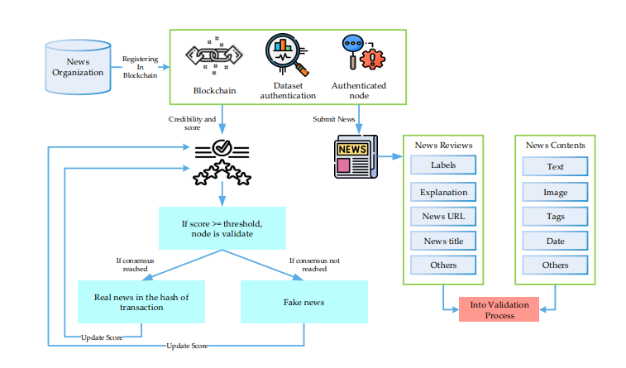

Fig 1: System Architecture

**4. RESULT SCREEN SHOTS**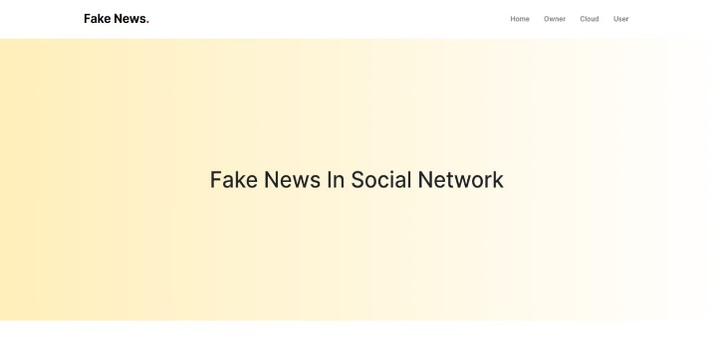



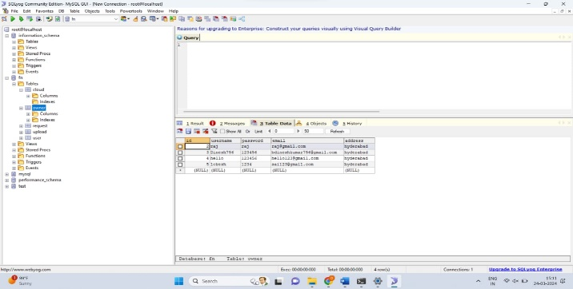



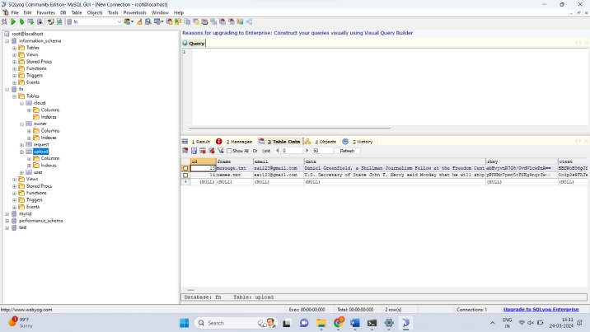

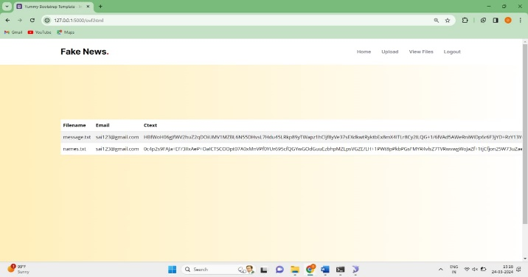

## 5. CONCLUSION

the proposed system offers a comprehensive solution to the pervasive issue of fake news on social media platforms by integrating machine learning algorithms, blockchain technology, and content verification mechanisms. Through advanced algorithms, the system enhances the accuracy of fake news detection, while blockchain ensures the integrity and immutability of user-generated content, preventing unauthorized modifications. Proactive content management tools empower administrators to swiftly address fake news posts, fostering a more responsible online community. By holding users accountable and promoting data integrity, the system aims to create a secure and trustworthy environment for information sharing, mitigating the harmful effects of misinformation on society.

Fake news sharing is one of the popular research problems in recent technology based on lack of security and trust in terms of the truth of shared news in social media. In this article, we have presented the combination of blockchain and machine learning techniques to provide solutions and design a trust-based architecture toward shared news online. We have applied the reinforcement learning technique, a learning-based algorithm, to make a strong decision-making architecture and combine it with blockchain framework, smart contract, and customized consensus algorithm, which is well fit for the Proof-of-Authority protocol. Social media plays a key role in this process. The shared information platform contains fake news, and its a beneficial challenge to enhance and investigate the Proof-of-Authority protocol and user validation

# 6. REFERENCES

[1] Vladimir P Miletskiy, Dmitry N Cherezov, and Elena V Strogetskaya. Transformations of professional political communications in the digital society (by the example of the fake news communication strategy). In 2019 Communication Strategies in Digital Society Workshop (ComSDS), pages 121–124. IEEE, 2019.

[2] Nicollas R de Oliveira, Dianne SV Medeiros, and Diogo MF Mattos. A sensitive stylistic approach to identify fake news on social networking. IEEE Signal Processing Letters, 27:1250–1254, 2020.

[3] Guanfeng Liu, Yan Wang, and Mehmet Orgun. Optimal social trust path selection in complex social networks. In Proceedings of the AAAI Conference on Artificial Intelligence, volume 24, 2010.

[4] Maria Nefeli Nikiforos, Spiridon Vergis, Andreana Stylidou, Nikolaos Augoustis, Katia Lida Kermanidis, and Manolis Maragoudakis. Fake news detection regarding the hong kong events from tweets. In IFIP international Conference on Artificial Intelligence Applications and Innovations, pages 177–186. Springer, 2020.

[5] Adline Rajasenah Merryton and Gethsiyal Augasta. A survey on recent advances in machine learning techniques for fake news detection. Test Eng. Manag, 83:11572–11582, 2020.

[6] Xishuang Dong, Uboho Victor, Shanta Chowdhury, and Lijun Qian. Deep two-path semi-supervised learning for fake news detection. arXiv preprint arXiv:1906.05659, 2019.

[7] Sachin Kumar, Rohan Asthana, Shashwat Upadhyay, Nidhi Upreti, and Mohammad Akbar. Fake news detection using deep learning models: A novel approach. Transactions on Emerging Telecommunications Technologies, 31(2):e3767, 2020.

[8] Pritika Bahad, Preeti Saxena, and Raj Kamal. Fake news detection using bi-directional lstm-recurrent neural network. Procedia Computer Science, 165:74–82, 2019.

[9] Giuseppe Sansonetti, Fabio Gasparetti, Giuseppe D’aniello, and Alessandro Micarelli. Unreliable users detection in social media: Deep learning techniques for automatic detection. IEEE Access, 8:213154–213167, 2020.

[10] Mohammad Mahyoob, Jeehaan Al-Garaady, and Musaad Alrahaili. Linguistic-based detection of fake news in social media. Forthcoming, International Journal of English Linguistics, 11(1), 2020.

[11] Abhishek Koirala. Covid-19 fake news classification using deep learning. 2020.

[12] Hyungjin Gill and Hernando Rojas. Chatting in a mobile chamber: effects of instant messenger use on tolerance toward political misinformation among south koreans. Asian Journal of Communication, 30(6):470–493, 2020.

[13] Jairo L Alves, Leila Weitzel, Paulo Quaresma, Carlos E Cardoso, and Luan Cunha. Brazilian presidential elections in the era of misinformation: A machine learning approach to analyse fake news. In Iberoamerican Congress on Pattern Recognition, pages 72–84. Springer, 2019.

[14] Nicollas R de Oliveira, Pedro S Pisa, Martin Andreoni Lopez, Dianne Scherly V de Medeiros, and Diogo MF Mattos. Identifying fake news on social networks based on natural language processing: Trends and challenges. Information, 12(1):38, 2021.

[15] Despoina Mouratidis, Maria Nefeli Nikiforos, and Katia Lida Kermanidis. Deep learning for fake news detection in a pairwise textual input schema. Computation, 9(2):20, 2021.

[16] Arvind Narayanan, Joseph Bonneau, Edward Felten, Andrew Miller, and Steven Goldfeder. Bitcoin and cryptocurrency technologies: a comprehensive introduction. Princeton University Press, 2016.

[17] Rohit Raturi. Machine learning implementation for business development in real time sector. International Journal of Pure and Applied Mathematics, 119(15):1289–1300, 2018.

[18] Bing Liu, Qingbo Zhao, Yueqiang Jin, Jiayu Shen, and Chaoyang Li. Application of combined model of stepwise regression analysis and artificial neural network in data calibration of miniature air quality detector. Scientific Reports, 11(1):1–12, 2021.

[19] Adam Karbowski. A note on patents and leniency. Gospodarka Narodowa, 301(1):97–108, 2020.

[20] J Antony Vijay, H Anwar Basha, and J Arun Nehru. A dynamic approach for detecting the fake news using random forest classifier and nlp. In Computational Methods and Data Engineering, pages 331–341. Springer, 2021.